JMK SHOWS For Immediate Release
6 PILGRIM DRIVE SUCCASUNNA , NJ 07876
(973) 927-2794 Cell (973) 224-2797 FAX (973) 927-2795
Director: Allison Kohler jmkshows@aol.com www.jmkshows.com

2011 NORTHERN VIRGINIA ANTIQUES SHOW BREAKS ATTENDANCE RECORDS UNDER NEW MANAGEMENT

Press Release – July 6, 2011

JMK Shows is pleased to announce the Northern Virginia Antique Show held June 25 & 26, 2011 in Arlington, Virginia enjoyed a significant boost in attendance. The show was managed by JMK for the first time in 2011. A fresh approach and aggressive marketing campaign led to an attendance increase of 30% over the previous year. It was the highest number of attendees in the last 5 years. The show, now in its 24th year, has been sponsored by the Kiwanis Club of Arlington since its inception, with a portion of the proceeds benefiting the organization.

JMK Shows has been in the antique show business since the early seventies. Allison Kohler, current owner and promoter, acquired JMK shows from her parents in 2001. Since then she has proven herself to be one the younger upcoming promoters of shows in the New Jersey, New York and Florida area. In the last 18 months, JMK has continued to build it’s roster of shows with The New Atlantic City Antiques Show and The White Plains Antiques Show as well as it’s already established Morristown Armory and Birchwood Manor shows. JMK was seeking to expand their business to the DC/Maryland & Virginia areas and delighted to acquire an established show in Arlington, Virginia. Dates for the 2012 show are: June 23 & 24 at the Thomas Jefferson Community Center, Arlington Virginia. Exhibitors are encouraged to sign up now for this re-energized event.

Contact numbers are: Ph. 973-927-2794, Cell 973-224-2797 Web site: www.jmkshows.com Email: jmkshows@aol.com.

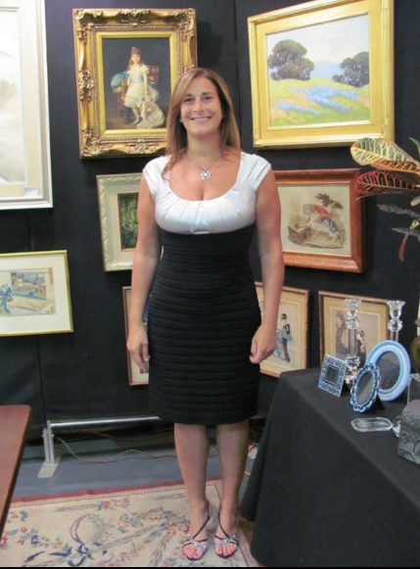
Owner Allison Kohler stands in one of the over 100 booths at the Northern VA
Antiques Show held June 25 & 26, 2011 – the newest show produced by JMK Events.

